Integrated Digital Systems Proposal

Prepared for:
United Nations and Religions World Organization (NRU)



Prepared by:
Docsecure Eswatini
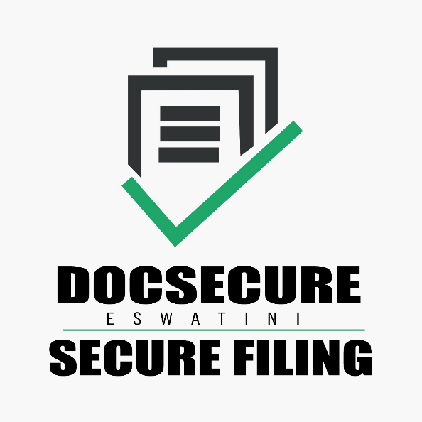
Date: 27 August 2026
This document summarises the functionality of four systems built for NRU — HRIS, EDMS, SPTS, and FLMS (Logistics) — as a proposal overview. Screenshots are inserted as demonstration of systems.

Executive Summary
NRU's operations span people management, records and document control, field-staff supervision, and vehicle fleet operations — historically four separate concerns, each prone to duplicated records, stale access lists, and paperwork that has to be re-typed from one department into another. This proposal covers four systems built to close that gap:
- HRIS — Human Resource Information System — the organisation's single source of truth for people, structure, and employment.
- EDMS — Electronic Document Management System — centralised, secure document capture, workflow, and records retention.
- SPTS — Smart Phone Tracking & Data Collection Monitoring — location-assured field operations and device management.
- FLMS — Fleet & Logistics Management System — vehicle, driver, fuel, and maintenance control.
The defining design decision across all four is that HRIS is the only place a person's identity, role, and organisational unit are ever entered. EDMS, SPTS, and FLMS each synchronise from HRIS rather than keeping their own user tables — so a new hire, a transfer, or a termination in HRIS propagates automatically everywhere, with no separate deprovisioning step to forget. This is what turns four applications into one coherent suite instead of four silos.

1. The Suite at a Glance
System | Full Name | Core Purpose | Status
HRIS | Human Resource Information System | People, org structure, payroll, leave, performance, recruitment | Production — in active use, verified end-to-end
EDMS | Electronic Document Management System | Document capture, versioning, workflow, retention, records compliance | Built — core modules functional
SPTS | Smart Phone Tracking & Data Collection Monitoring | Field-staff location assurance, geofenced check-in, device fleet, internal calling | Built — core modules functional
FLMS | Fleet & Logistics Management System | Vehicle registry, driver management, fuel control, maintenance, dispatch | Built — core modules functional
[Placeholder — suite overview / login screens montage]

2. Why One Suite, Not Four Applications
- Single identity backbone. EDMS, SPTS, and FLMS all authenticate against HRIS-sourced identity — roles, job titles, and organisational units are pulled in (nightly and on demand), never re-entered. A person who leaves the organisation in HRIS loses access to every other system automatically.
- Consistent access model. All four use role-based access control scoped to organisational unit — not a blanket admin/everyone-else split — so a department head only ever sees their own department's people, documents, patrols, or vehicles.
- Shared audit discipline. Every privileged action across the suite — a permission change, an approval, a fuel transaction, a document access — is logged with a full before/after trail, not just a "something happened" line.
- Shared internal calling. SPTS and FLMS both ship the same peer-to-peer voice-calling module, so field and fleet staff can reach each other directly from the app with no telephony contract or per-minute cost.
- Financial continuity. FLMS fuel transactions are built to flow directly into the organisation's accounting ledger once verified by a fleet officer, rather than being re-keyed from paper fuel logs.

3. HRIS — Human Resource Information System
HRIS is the organisation's system of record for its people: every employee's profile, employment history, reporting line, and access rights live here, and every other system in the suite treats it as authoritative.
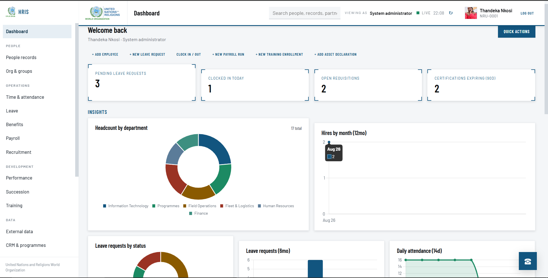
[HRIS dashboard]
People & Organisation
- Full employee profiles with photo, contact, and next-of-kin details
- Versioned employment history (position, grade, department changes tracked over time, not overwritten)
- Teams-style interactive org chart with manager/peer/direct-report views, independently audited manager-reassignment trail
- Self-service profile editing with field-level restrictions (employees edit their own contact details; HR/managers retain full access)
Time, Leave & Benefits
- Self-service clock-in/out and worktime tracking
- Leave request, approval, and balance tracking
- Benefits administration
Payroll
- Full pay-run lifecycle (draft → processed → closed), bulk payline generation
- Self-service payslip access, scoped so employees only ever see their own pay
Talent
- Recruitment pipeline, performance reviews (self-rating and manager-rating on the same record, each editable only by the correct party), succession planning, training records
Partner & Programme Management
- Partner organisation and programme intake, lightweight CRM for external relationships
Security & Access
- Role × module permission matrix with per-field data scope (self / team / department / organisation / programme)
- Multi-factor authentication — authenticator app (TOTP), email one-time codes, single-use backup codes, account lockout after repeated failures
- Field-level encryption at rest for sensitive data (national ID, next-of-kin phone, bank account, tax number)
- HTTPS-ready with security headers on by default
Internal Calling (VoIP)
- Extension provisioning, department routing, hunt groups, call-handling preferences, directory-integrated dialling
Reporting & Audit
- 14 report types (workforce, attendance, leave, payroll, recruitment, training, performance, benefits, succession, certifications, partners, programme indicators, calling activity, declarations)
- Combined multi-report exports (PDF, Excel, CSV) with a formal letterhead layout, plus saved/reusable report configurations
- Full audit trail with readable before → after change comparisons, exportable
Configuration
- Company-configurable identity (organisation name, logo, employee numbering scheme) — not hardcoded to any one deployment
- Admin-manageable roles and dashboards with 9–10 live interactive charts (headcount, hiring trend, leave, attendance, payroll, recruitment funnel, training completion)
[Placeholder — org chart / payroll / reports screens]
Status: Production-ready. Verified end-to-end against a running instance — login, every module, payroll state machine, permission matrix, mobile responsiveness, and scope-correctness (a department-scoped user was confirmed to see only their own department's data across reports and dashboards).

4. EDMS — Electronic Document Management System
EDMS is a centralised, secure home for the organisation's documents and records — replacing scattered shared drives and email attachments with a single governed repository that captures, versions, routes, and eventually retires every document under a consistent policy.
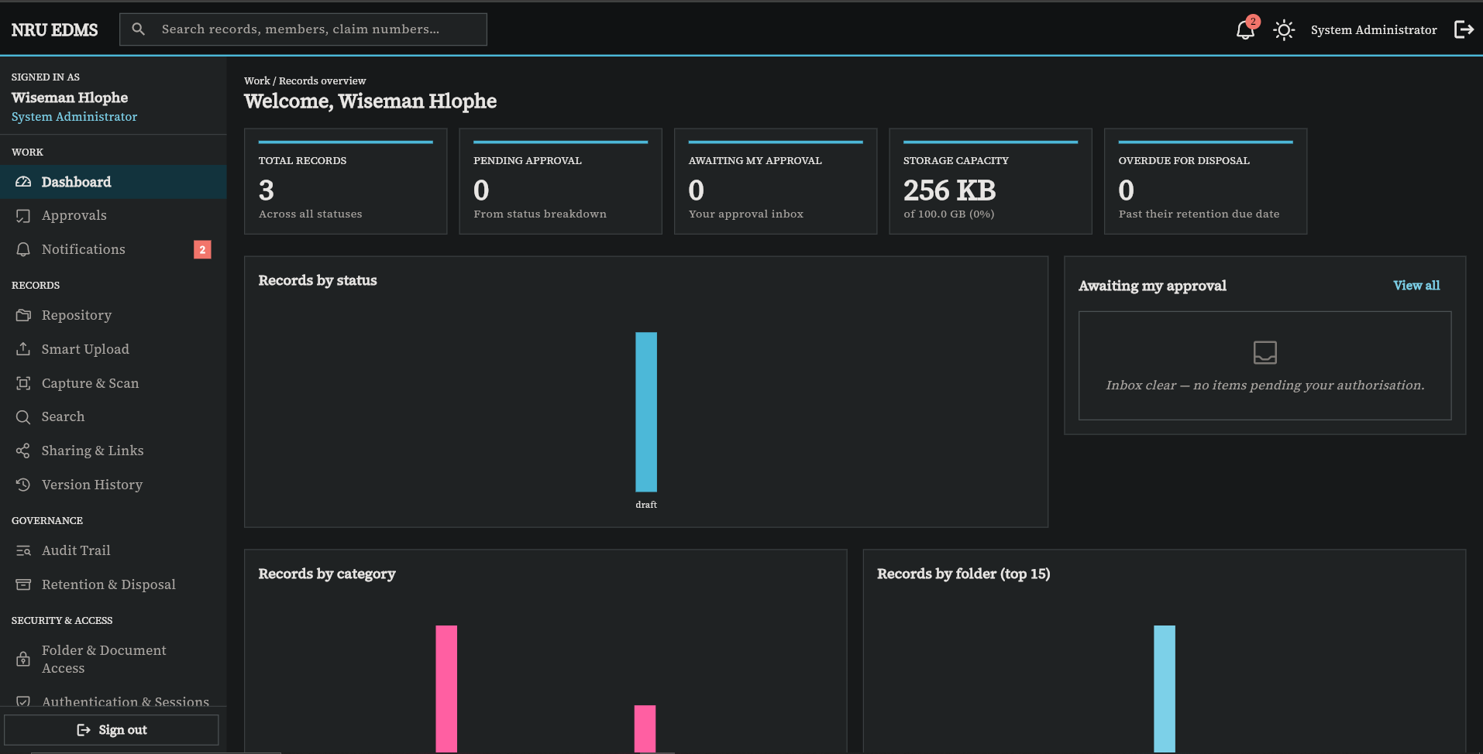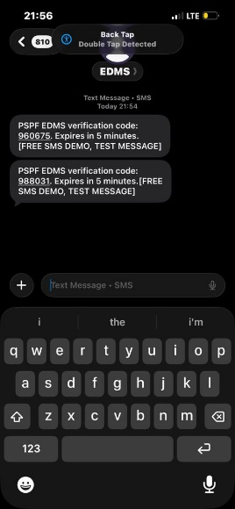
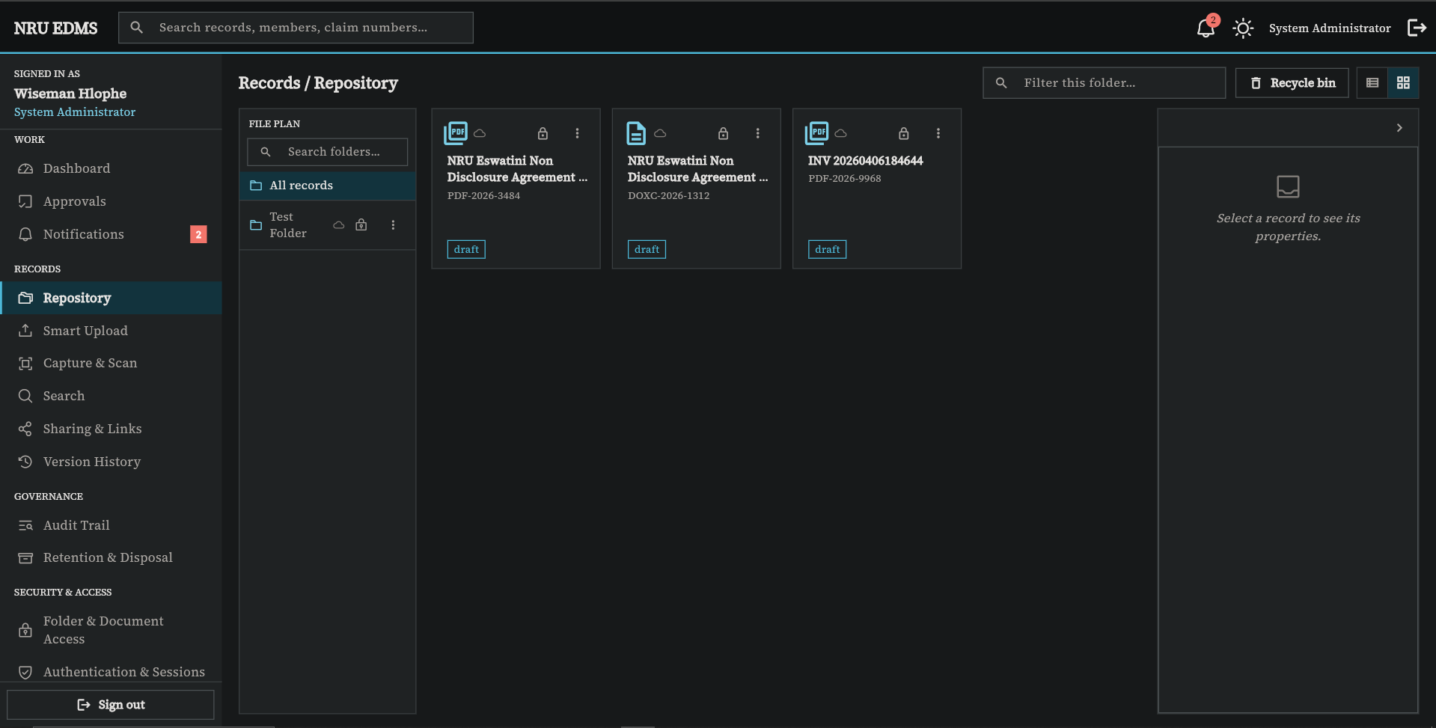
[EDMS Dashboard, SMS Notifications, repository]
Document Management
- Folder hierarchy with document registration, upload, and metadata
- Full version history with restore to any prior version
- "Declare final" record-locking to freeze a document once it's official
- Duplicate detection via content hashing
- In-app document viewer
Automated Capture
- Manual upload, watched-folder intake, email intake, and FTP intake — documents can flow in automatically from scanners, shared inboxes, or file drops, not just manual upload
- Batch capture with live connector-status monitoring and exportable capture summaries
Intelligent Processing
- Automatic OCR text extraction on every upload, feeding full-text search across the repository
- Smart Upload: rules-based classification suggests a document type from its OCR text for a human to confirm before filing
Workflow & Approvals
- Visual workflow designer for building approval routes
- Workflow instances started directly against a document
- Approvals inbox (approve/reject) and an access-request flow for permission grants
Security & Access
- Role-based access control combined with per-folder and per-document permissions (view / comment / edit / approve / full control)
- Document classification levels — public, internal, restricted, confidential
- Multi-factor authentication (authenticator app, SMS, email, backup codes)
- Google and Microsoft single sign-on for provisioned accounts
- Envelope encryption at rest (AES-256-GCM) with a rotatable master key — documents are never written to storage unencrypted
Records & Compliance
- Configurable retention classes and a disposal queue for end-of-life records
- Hash-chained, tamper-evident audit log with a built-in chain-verification check — not just a log table, but one that can prove it hasn't been altered
Sharing
- Internal sharing plus public share links that are time-bound and permission-scoped
Administration & Operations
- Multi-tenant-ready architecture, department/user/group management, branding customisation
- Licensing module (trial / standard / enterprise tiers, activation and validation)
- Scheduled jobs for backup, workflow processing, and capture batches; built-in backup and restore
- Integrations hub with status dashboard for Active Directory, HRIS, email, SMS, and cloud storage
- Storage is provider-agnostic — AWS S3, Azure Blob, Google Cloud Storage, or local disk, switchable without code changes
Cross-Platform Access
- One Flutter codebase delivers the same application as a web app, a Windows desktop app, and a mobile app
- A companion developer documentation and live API sandbox site is available for technical integration partners
[Placeholder — workflow designer / mobile & desktop client]
Status: Core modules (capture, versioning, workflow, security, retention, audit) are built and functional. A small number of advanced items are earmarked for the next phase rather than complete today: WebAuthn/security-key sign-in, Microsoft SSO token verification, on-premise Active Directory bind, and a dedicated redaction/watermarking interface.

5. SPTS — Smart Phone Tracking & Data Collection Monitoring
SPTS gives NRU provable assurance over its field operations: it confirms exactly where an organisation-issued handset and the staff member carrying it are, before that person can begin recording field data, and keeps a defensible record of every check-in, zone, and device.
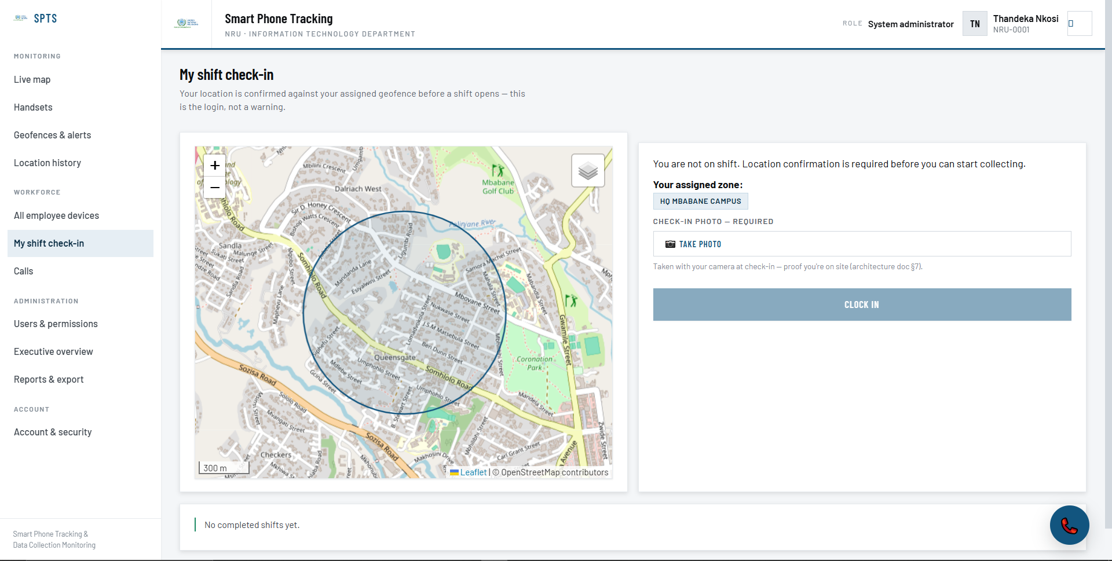
[SPTS shift check-in]
Enforced Presence & Check-In
- Server-side geofence gate — a field worker cannot access the app's work screens until their GPS position is confirmed inside their assigned zone; a failed check shows exactly how far outside the zone they are
- Photo/selfie proof required at check-in
- Periodic re-confirmation of location (configurable interval), always re-checked on a fresh login
- Supervisor override for exceptional out-of-zone check-ins, fully attributed and audited
- Shift-hour gating — check-ins are blocked outside configured working hours
Live Map & History
- Real-time map of on-shift staff and devices with geofence boundaries overlaid
- Historical shift playback — the full GPS track of any past shift, rendered on a map
- Zone entry, exit, and dwell events logged and searchable
Zones, Devices & Staff
- Zone management — create, assign, and manage geofenced areas with configurable rules (check-in required, exit alert, dwell alert, entry log)
- Handset registry — asset tag, IMEI, model, live status, battery and signal level, assignment to employees
- Organisation-wide staff directory synchronised from HRIS
Alerts & Reporting
- Severity-tiered alerts tied to staff, devices, or zones, with a resolution workflow
- CSV export of check-ins and alerts, automatically scoped to the viewer's department
Executive Oversight
- An executive dashboard showing aggregate KPIs only (headcount on shift, active zones, open alerts, device status) — individual staff locations are deliberately never exposed at this level, a privacy safeguard built into the system rather than a policy relying on user discretion
Internal Calling (VoIP)
- Genuine peer-to-peer voice calling between staff over the data connection, with no telephony contract
- Automatic online/idle/offline presence, full call history per person
Status: Core system — enforced check-in, geofencing, live map, device/staff/zone management, alerts, reporting, and internal calling — is built and functional today as a browser-based application. A native offline-first mobile app (with anti-tampering and cryptographically verified location photos) is the defined next phase for areas with unreliable connectivity.

6. FLMS — Fleet & Logistics Management System
FLMS brings the same discipline to NRU's vehicle fleet that HRIS brings to its people — one register for every vehicle and driver, controlled fuel issuance, tracked maintenance, and trip authorisation that leaves a paper trail.
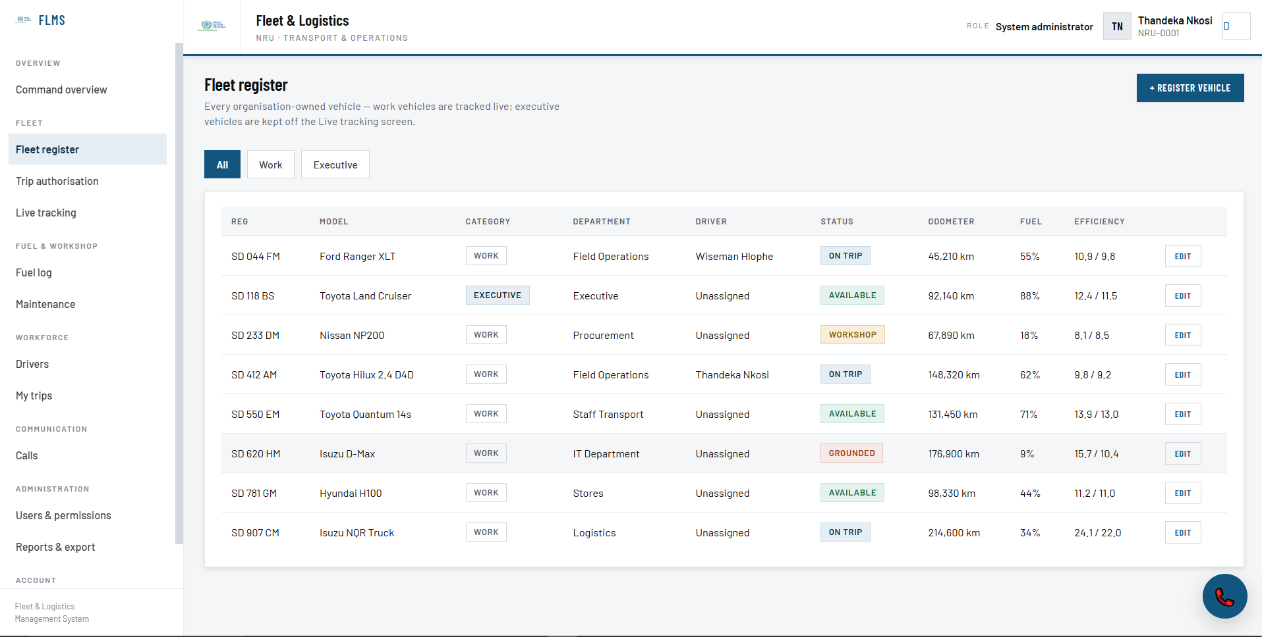
[FLMS fleet register ]
Fleet & Drivers
- Full vehicle registry — registration, model, category (work or executive), assigned driver, department, odometer, fuel level, efficiency against target, next service due, and live status (available / on trip / in workshop / grounded)
- Driver profiles layered on HRIS identity, with licence tracking and an internal safety score
Trip Authorisation
- Self-service trip requests from any employee, routed through approval to completion, with distance, purpose, and cost captured throughout
Fuel Control
- Fuel transaction capture (station, litres, rate, odometer) with automatic exception flagging — overfills against tank capacity and implausible refill intervals are caught before they're approved
- Fleet-officer verification step before a transaction is treated as final
Maintenance
- Workshop work orders with priority levels and a scheduled → in-workshop → completed lifecycle
- A vehicle with an open high-priority work order is automatically blocked from being dispatched
Live Tracking
- Real-time map of the operational (work-category) fleet
- Executive vehicles are deliberately excluded from live tracking as a governance safeguard
Policy & Administration
- Configurable dispatch and fuel policy — off-hours fuel blocking, mandatory odometer photo, station geofencing, automatic overfill flagging, variance thresholds, and a fuel price ceiling
- Admin-editable role permission matrix and on-demand HRIS reconciliation
Financial Integration
- Fuel transactions are designed to post directly into the organisation's accounting ledger once verified, with a held "exceptions" queue for anything flagged, so nothing questionable reaches the books unreviewed
Internal Calling (VoIP)
- The same internal calling module used in SPTS, for dispatchers and drivers to reach each other directly
Status: Built to the same standard as HRIS and SPTS — every module has working CRUD, permission gates, and a complete data model. As the newest of the four systems, it has not yet been load-tested under live operational traffic, and the fuel-to-ledger posting integration is wired for but should be confirmed end-to-end before go-live.

7. Common Security & Governance Model
The same principles run through all four systems, by design rather than by coincidence:
- One identity source. HRIS provisions and revokes access everywhere else — one join or leave event, not four.
- Scoped access control. Every role is bounded to an organisational unit; nobody sees more than their role and department justify.
- Full audit trails. Every privileged action is logged with before/after detail across all four systems; EDMS additionally makes its log tamper-evident via hash-chaining.
- Multi-factor authentication available across the suite.
- Encryption at rest for the most sensitive data — national IDs and bank details in HRIS, entire documents in EDMS.
- Privacy-by-design carve-outs — SPTS executives see aggregate numbers only, never an individual's location; FLMS excludes executive vehicles from live tracking.

8. Technology Summary
System | Backend | Database | Frontend | Notable Technology
HRIS | Node.js / Express | MySQL | Web (HTML/JS) | Field-level AES-256-GCM encryption, PDFKit/ExcelJS reporting
EDMS | Node.js / Express | MySQL | Flutter — Web, Windows desktop, Mobile | Multi-cloud storage (AWS/Azure/GCP/local), envelope encryption
SPTS | Node.js / Express | MySQL | Web (HTML/JS) | WebRTC peer-to-peer calling, geofencing
FLMS | Node.js / Express | MySQL | Web (HTML/JS) | WebRTC calling, live map tracking (Leaflet)
All four share the same architectural philosophy: no ORM, direct SQL for transparency and performance, and a consistent role/scope permission model implemented the same way in every codebase — which keeps the systems maintainable as one family rather than four unrelated products.

9. Roadmap — Next Phase
System | Planned Next
EDMS | WebAuthn/security-key sign-in, verified Microsoft SSO, on-premise Active Directory integration, dedicated redaction & watermarking interface
SPTS | Native offline-first mobile app, anti-tampering and mock-location detection, cryptographically verified location photos, polygon (not just circular) geofences
FLMS | Load testing under live operational traffic, end-to-end confirmation of the fuel-to-ledger posting integration
HRIS | Optional blank-install mode for future deployments beyond NRU

10. Closing
Together, HRIS, EDMS, SPTS, and FLMS give NRU a single coherent operating layer: one place people are managed, one place documents are governed, one place field presence is verified, and one place the vehicle fleet is controlled — all drawing from the same identity source and held to the same security and audit standard. Each system stands on its own today; together, they remove the re-keying, stale-access, and paper-trail gaps that come from running separate, disconnected tools.

